ST. BEDE’S CATHOLIC JUNIOR SCHOOL
celebrates life and learning

SCHOOL UNIFORM POLICY

AUTHOR: | MRS. F. TIERNAN
APPROVAL DATE: | MAY, 2023
REVIEWED: | ANNUALLY
NEXT REVIEW: | MAY, 2024

ST. BEDE’S CATHOLIC JUNIOR SCHOOL
celebrates life and learning

SCHOOL UNIFORM POLICY

MISSION STATEMENT

St. Bede, patron of our school, wrote:

“It was always my delight to learn and to teach”.

We are a celebrating community, living the
Gospel Values, committed to educating children
in the light of the Catholic Faith.

We journey together so that we

“Might have life - life in all its fullness”.

John 10:10

RATIONALE
It is our Policy that all children should wear school uniform when attending school or when participating in a school-organised event outside normal hours. The intention is to create a fashion-conscious free environment in which children can work, play and grow. Fashion can polarise those families that can afford designer clothing, footwear and trendy hairstyles from those for whom peer pressure can often be a greater financial burden. School uniform makes a very strong commitment to appropriateness and equality.
A complete list of the items needed for school uniform is in our school prospectus and on our website:
The school leadership, including governors, has given consideration to the ‘Cost of school uniforms’ on the GOV.UK website. Cost of school uniforms - GOV.UK (www.gov.uk).
The guidance outlines the cost considerations which schools should consider when:
- developing and implementing their uniform policies
- managing their uniform supplier arrangements
It also covers:
- the provision of second-hand uniform
- other support with the cost of school uniforms
- the information schools should provide to parents regarding their uniform requirements.

This guidance is issued under the Education (Guidance about Costs of School Uniforms) Act 2021. This Act requires the appropriate authorities of relevant schools to have regard to this guidance when developing and implementing their school’s uniform policy.
The Governing Body has also considered the cost of uniform so that it does not deter applications to the school. This includes PE kit along with the wearing of PE uniform twice a week (for PE lesson days).

PURPOSES
Our Policy is based on the notion that a school uniform:
- promotes a sense of pride in the school;
- engenders a feeling of community and belonging;
- is practical and smart;
- identifies the children with the school;
- is not distracting in class (as fashion clothes may be);
- makes children feel equal to their peers in terms of appearance;
- is regarded as suitable, and good value for money, by most parents/carers;
- has been designed with health and safety in mind.

COSTS
The school uses two suppliers for school uniform: Boydell’s, Widnes and Touchline, Warrington (Touchline UK - Homepage (touchline-embroidery.com).
The items unique to the school are:
- School jumper/cardigan, with school badge
- Tartan pinafore, kilt or pleated skirt
- School hoodie (optional for PE)
- School PE top (with school badge)
NB: All pupils are issued with a school tie when they join the school.
Other uniform items, which are universally available, include:
- White shirt
- Grey trousers (not skinny jeans, nor black trousers)/ grey shorts
- Summer uniform: green gingham dress (not skort style, nor stripes, nor white top and check bottom)
- White polo shirt
- Black PE short/ black joggers (plain with no logo)/black leggings
- Black shoes (not trainers/boots)
On PE/Sport days, pupils can wear trainers.

Jewellery
On health and safety grounds we do not allow children to wear jewellery in our school. The exception to this rule is a watch. The children must remove the watch during PE and games. We ask that ears are pierced during the summer holidays so that earrings can be removed at home. Once the six-week period has elapsed, they must not be worn in school. If they are, for a short time, they need to be covered with tape.

Hair and Make Up

The school does not allow any of the following:
- Haircuts that could serve as a fashion statement, distraction to others or to identify children as part of a particular group (Mohicans, zig-zags, skinheads, etc.);
- Shaven heads beyond No.2;
- Long hair which is not tied up/back;
- Hairbands, hair-bows, bobbles, which are unnecessarily decorated and/or coloured (these cause distractions unnecessarily too);
- Tattoos / transfers;
- Hair gel or hair products such as colour/dye;
- Extensions/braids which include beads;
- Make-up, including nail varnish and/or artificial nails.

Footwear

To ensure the safety of all children, the development of healthy feet and promote smart appearance, the school requires that traditional black shoes are worn.

The following will not be accepted:
- Boots, high or ankle;
- High heels or platform soles;
- Shoes which resemble trainers and have sporting stripes or icons on them;
- Wellingtons/boots may be worn for the journey to and from school but children are required to change into shoes or pumps during the school day.

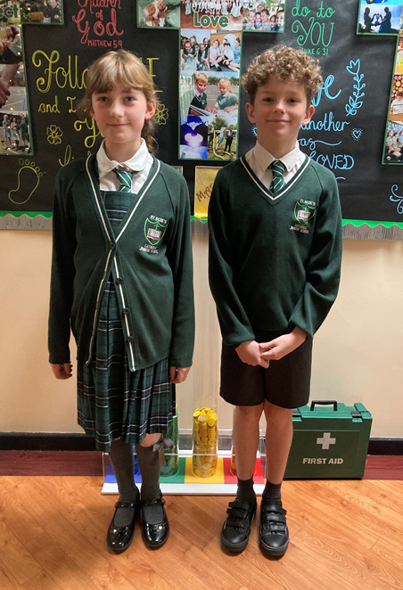

DONATED ITEMS OF SCHOOL UNIFORM

Many parents/carers donate items of school uniform in good condition that their child(ren) have outgrown. These are available for any child and/or parent/carer free of charge.

The role of parents/carers

Parents/carers who send their children to our school are expected to support the School Uniform Policy. We believe that parents/carers have a duty to send their children to school correctly dressed and ready for their daily schoolwork. Parents/carers should ensure that their child has the correct uniform, and that it is clean and in good repair.

If any parent/carer would like the school to modify the uniform policy, he/she should make representation, in the first instance, to the Headteacher. The school welcomes children from all backgrounds and faith communities. If there are serious reasons, for example religious objections, why parents/carers want their child to wear clothes that differ from the school uniform the school will consider such requests sympathetically. Similarly, should an item of school uniform prove problematic for a pupil with disabilities then parents/carers are invited to draw this to the attention of the Headteacher.
The role of governors

The Governing Body supports the Headteacher in implementing the School Uniform Policy. It considers all representations from parents/carers regarding this Policy, and liaises with the Headteacher to ensure that the Policy is implemented fairly and with sensitivity. It is the Governors’ responsibility to ensure that the school uniform meets all national regulations concerning equal opportunities, and that our School Uniform Policy is consistent with our Policy on Equal Opportunities. Governors ensure that the School Uniform Policy helps children to dress sensibly, in clothing that is hardwearing, safe and practical.

The Department for Education strongly recommends that Governing Bodies:
- engage with parents and pupils when designing their uniform policy or when making any significant changes - these views should be considered in determining the final policy.
- consider how the introduction of the proposed uniform policy might affect groups represented in the school, especially those who share protected characteristics as defined by the Equality Act 2010
- consider how comfortable the proposed uniform will be for pupils.
- take a sensible approach to allow for exceptions to be made during extreme weather, for example, allowing pupils to wear shorts in very hot weather or allowing trousers to be worn instead of skirts in very cold weather.
- ensure that their uniform is suitable and safe for pupils who walk or cycle to school, for instance, by allowing pupils to wear a coat which they could be visible in when it is dark going home.
- choose a PE kit which is practical, comfortable, appropriate to the activity involved and affordable.
- ensure the final policy is published on the school’s website so it is easy for parents (including parents of prospective pupils) to access and understand.

REVIEW

The School Uniform Policy will be reviewed in the light of guidance, training and changes in legislation or at the request of a member of the school community. The staff and Governing Body will agree any amendments.
ST. BEDE’S CATHOLIC JUNIOR SCHOOL
celebrates life and learning

SCHOOL UNIFORM

The table below indicates the appropriate dress code and items that are not allowed.

‘V’ neck pullover or cardigan | Bottle green with silver trim to V | With school logo
Shirt | White
Skirt/pinafore | Green/black tartan pleated skirt, Green/black tartan kilt or Green/black tartan pinafore
Tie (worn at a reasonable length) | Bottle green and silver striped
Trousers or shorts | Grey | Must be a traditional formal ‘suit’ style trouser (no canvas, cargo or jeans style). NB:
Tights | Black/grey/bottle green | Plain, no patterns.
Footwear | Black  No logos | Traditional/formal style in leather or synthetic. No trainers/trainer style shoes or UGG style boots.  Traditional black sandals may be worn in the summer time.
Socks | Grey / white
P.E Kit | Black and green top and black shorts/black jogging bottoms/leggings
OPTIONAL
Fleece jacket | Embroidered with school badge
Hooded sweatshirt | Embroidered with school badge
In summer a green/white gingham dress, short grey trousers, short sleeved blouse or a white polo shirt are permissible.
Jewellery | Only a watch is permissible.
Make up | Make up in any format is not allowed.
Hair | Natural colour only |  | No ‘extreme’ styles are allowed.

SUPPLIERS

School uniform can be purchased from:

Boydells Sports (0151 424 3257)
17 – 19 Victoria Road, Widnes, WA8 0PU.

Touchline UK (01925 413777)
Unit 2, Kerfoot Street, Warrington, WA2 8NU.

